# 

# 

# 

User Interface Design Document

*Project Planner* [Working Title]

**Client**

Doug Craig

**Team Hailstorm**

Hemang Bhatt

Aidan Gray

Cameron Hensel

Jonathan Love

Jacob Lutz

Phuoc Nguyen

Nirav Pancholi

25 October, 2017

|  |  |
| --- | --- |
| **Table Of Contents** | Page |
| 1. Introduction | 2 |
| 1.1 Purpose of this Document | 2 |
| 1.2 References | 2 |
| 2. User Interface Standards | 2 |
| 3. User Interface Walkthrough | 3 |
| 3.1 Navigation Diagram | 3 |
| 3.2 Application Walkthrough | 4 |
| 4. Data Validation | 9 |
| Appendix A - Agreement between Customer and Contractor | 10 |
| Appendix B - Team Review Sign-Off | 12 |
| Appendix C - Document Contributions | 14 |

## 

## **1. Introduction**

### 1.1 Purpose of This Document

This document is designed to provide a description of the navigation and use of the *Project Planner* application’s user interface by displaying a layout of the various webpages and how they are linked. It is intended for readership by Team Hailstorm members as well as the client, Doug Craig.

### 1.2 References

This document makes references to the *Project Planner* System Requirements Specification document.

## 2. **User Interface Standards**

This section provides an overview of the primary design standards of the *Project Planner* application. An example of the webpage can be seen in Figure 1, where the main aspects of the layout are displayed. The company logo will be displayed in the top left corner of each screen and the application title will be at the top center. To allow users the ability to sign out of the application at any time; there will be a sign out button located in the top right of each screen. On each screen there will be buttons that the user can use to navigate between pages, and these will all be underlined so that the user will easily be able to identify which words are buttons and which are not.

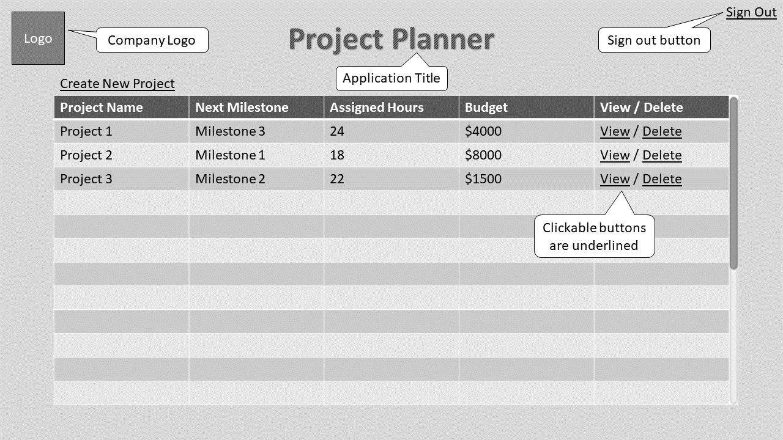

*Fig. 1 - UI Standards*

## 3. **User Interface Walkthrough**

### 3.1 Navigation Diagram

The following diagram, Figure 2, displays how a user could navigate the application by displaying the possible screens and how they are connected.

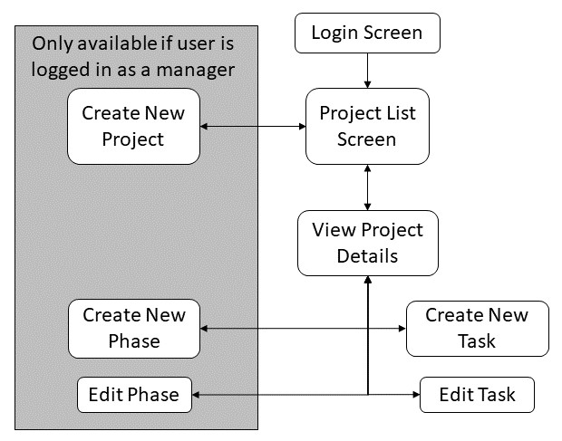

*Fig. 2 - Navigation Diagram*

From the login screen, the user is presented with the list of projects. If the user is a manager, this list will display all of the projects, whereas if the user is an employee, only the projects they are assigned to will be displayed. Additionally, managers will be able to delete and create new projects from this screen, but both managers and employees can choose to view the project details. At the project details screen, the user has the ability to create new tasks, edit existing tasks, or request deletion of a task. If the user is a manager, they can also create new phases.

### 3.2 Application Walkthrough

The first screen that the user will be presented with is the login screen, shown in Figure 3. On this screen the user will be presented with two text entry boxes for their username and password, along with a button to sign in, and a button if they have forgotten their password.

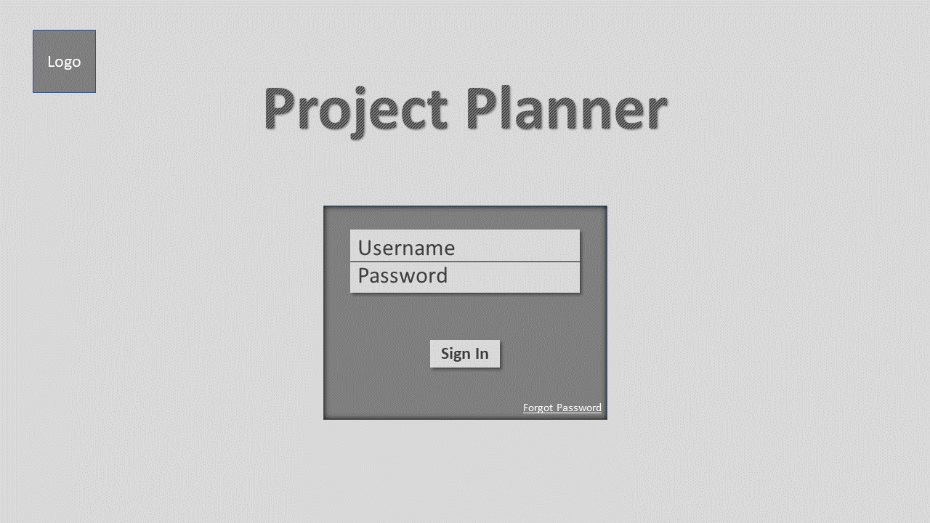

*Fig. 3 - Login Screen*

After signing in, the user is directed to the project selection screen, shown in Figure 4. At this screen the user can see a list of all current projects, along with some overall information about them such as remaining budget, estimated hours, and the next milestone. Managers will have the ability to create and delete projects by clicking those buttons, and both the managers and the employees will be able to view the project details.

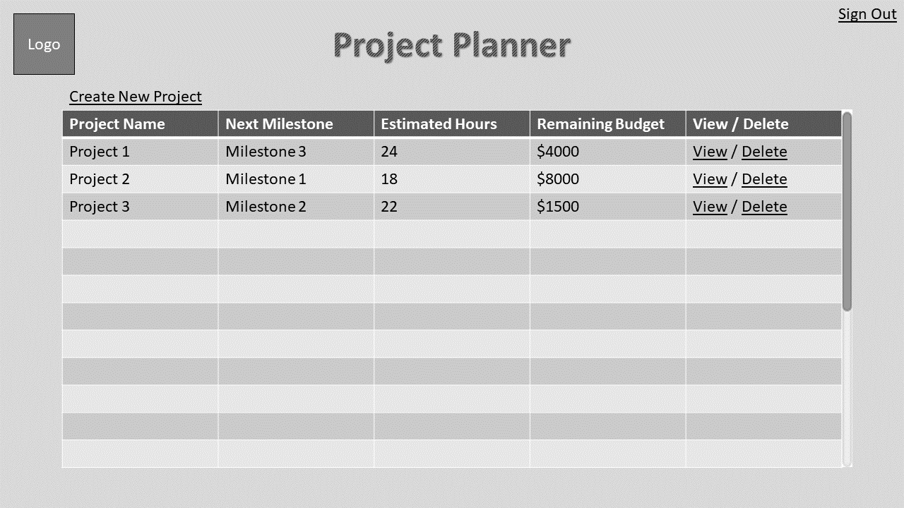

*Fig. 4 - Project Selection Screen for Managers*

If the user has chosen to create a new project, Figure 5 is the screen they will see next. On this screen the manager can enter in the project’s title, total budget, phase(s), milestone(s), and description. If they would like to add more phases or milestones, they can click those buttons to add another text field. Once complete, the user can save the project or cancel and go back to the project selection screen.

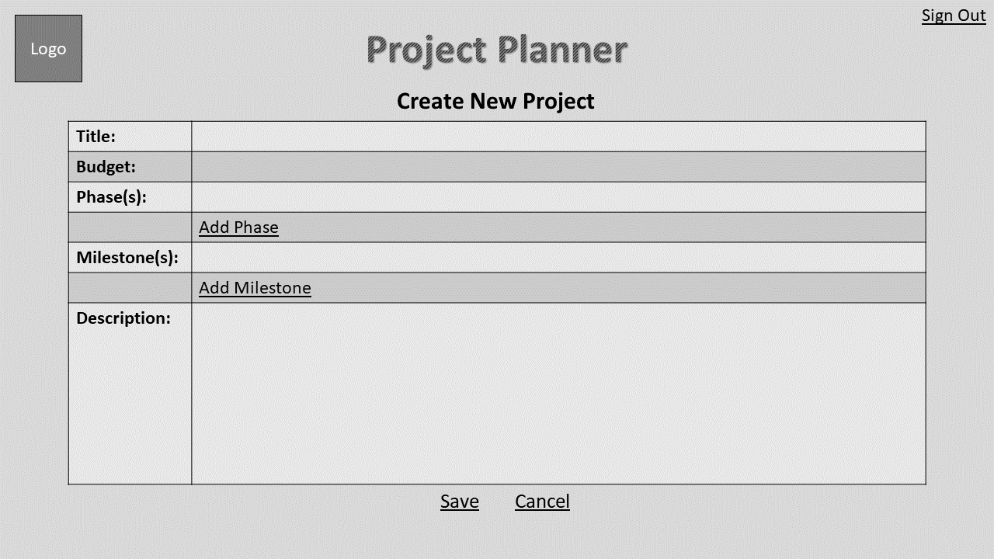

*Fig. 5 - Project Creation Screen*

Figure 6 below shows the project selection screen displayed to the employees, showing that the buttons for create new project and delete project are missing.

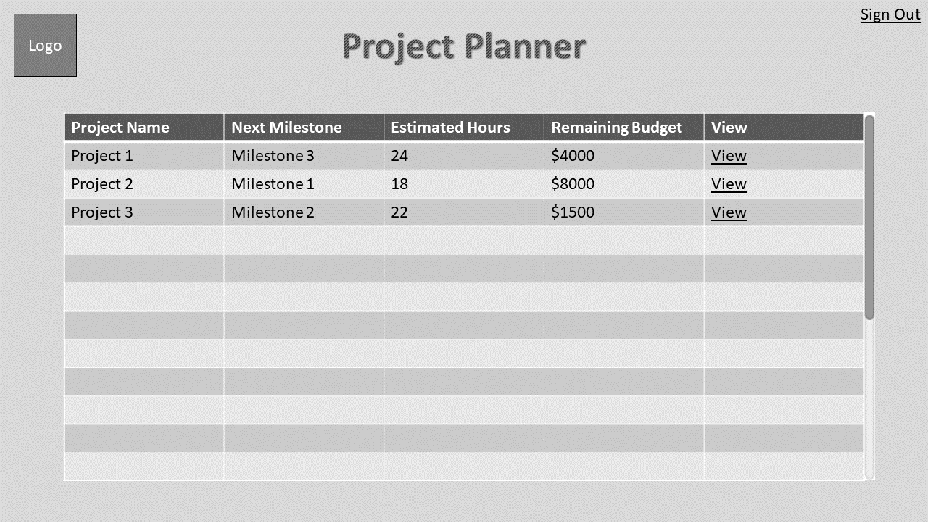

*Fig. 6 - Project Selection Screen for Employees*

After selecting a project to view, the following screen, Figure 7, will be displayed. This screen presents the user with a navigation window on the left and the information to display on the right. In the navigation window the user can select which tasks/phases to view, as well as the ability to create new phases and tasks. The initial screen includes the overall project details. If the user has selected a task, as shown in Figure 8, the right side of the screen will display all of the information related to that task, as well as give the user the ability to edit the task or request deletion of the task.

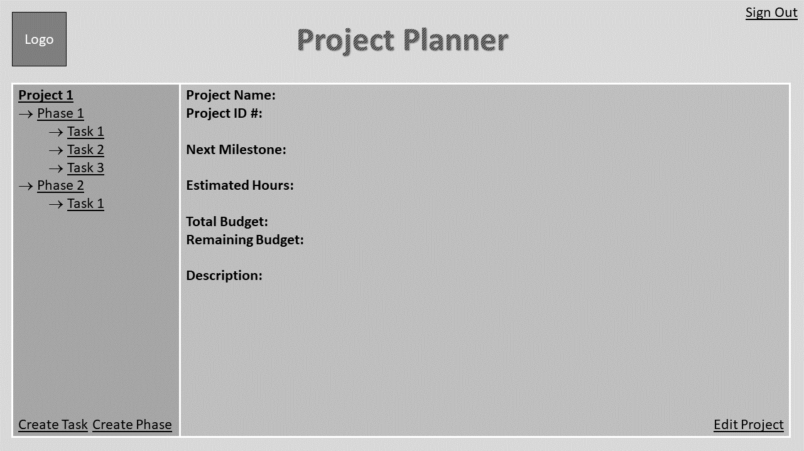

*Fig. 7 - Project Description Screen*

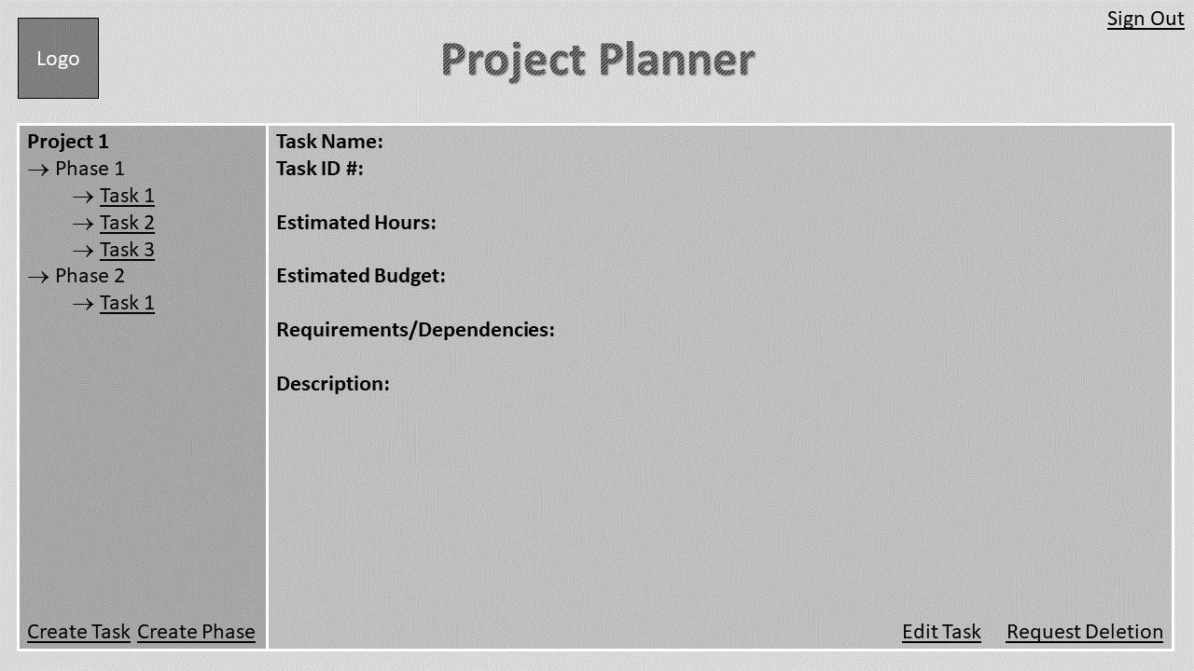

*Fig. 8 - Task Description Screen*

Choosing to create a new phase will present the user with the screen shown in Figure 9. The user has the ability to enter the name of the phase and description. The user can then choose to save the new phase or cancel the phase creation.

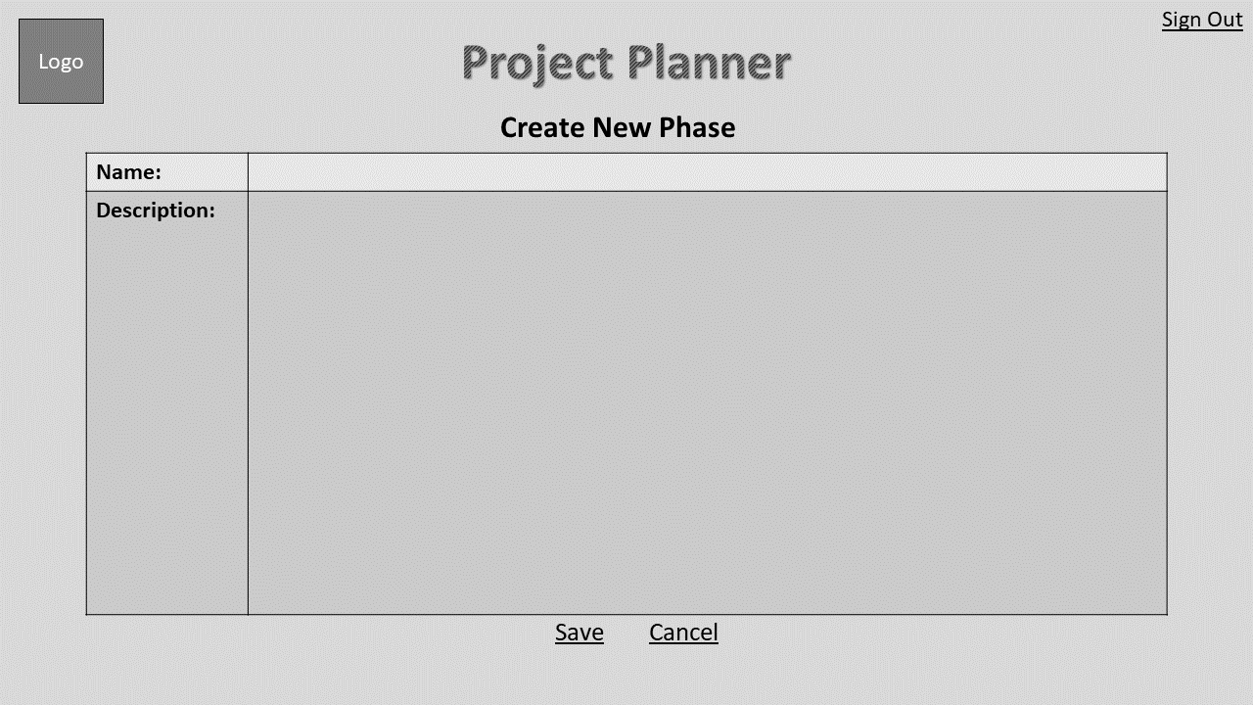

*Fig. 9 - Phase Creation Screen*

Choosing to create a new task will present the user with the screen shown in Figure 10. The user has the ability to enter the name of the task, estimated hours, estimated budget, requirements, and description. The user can then choose to save the new task or cancel the task creation.

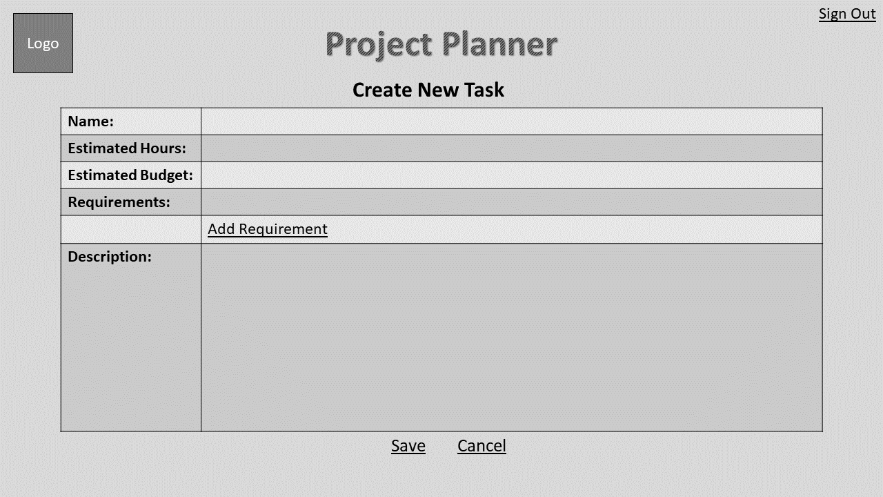

*Fig. 10 - Task Creation Screen*

To edit a task, the user can select the “Edit Task” button and be presented with the screen shown in Figure 11, which is identical to the creation of a new task but will allow the user to change the values already present for that task.

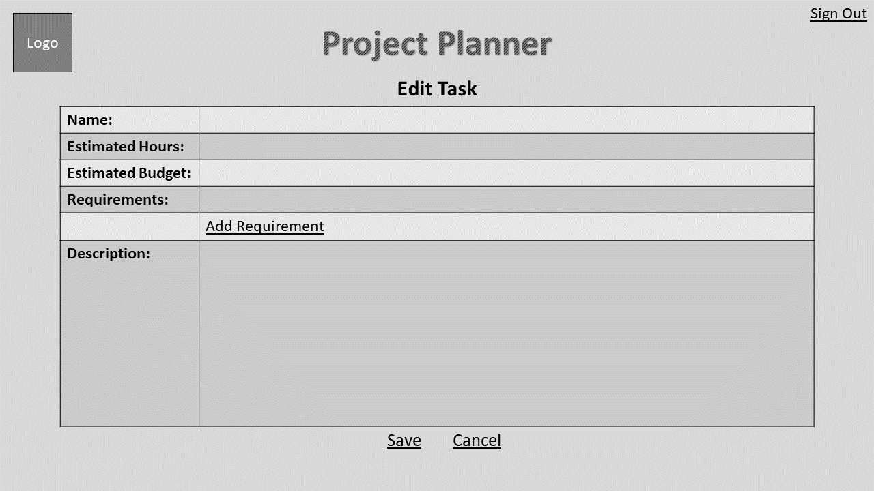

*Fig. 11 - Task Edit Screen*

After saving or cancelling the task creation, the user will be redirected to the Figure 7, the screen displaying all of the project’s details. This allows them to continue editing and viewing the project’s details.

## **4.** **Data Validation**

The *Project Planner* application requires multiple points of data entry by users throughout the system. The user will enter data upon the creation of any project or attribute, and this data may be edited in the future from the same data entry points. Please see the table below for a list of locations in which the user may enter data, and the limitations on each data entry point.

|  |  |  |
| --- | --- | --- |
| **Entry Location** | **Data Type** | **Limits** |
| Project Title | String | Less than 30 characters |
| Project Description | String | Less than 1000 characters |
| Project Budget | Integer | Greater than 0 |
| Phase Title | String | Less than 30 characters |
| Phase Description | String | Less than 1000 characters |
| Milestone | String | Less than 30 characters |
| Task Title | String | Less than 30 characters |
| Task Description | String | Less than 1000 characters |
| Task Requirements | String Array | Less than 100 characters per requirement, limited to 10 requirements per task. |
| Hours | Integer | Greater than 0 |

## 

## 

## **Appendix A – Agreement Between Customer and Contractor**

The client agrees to a *Project Planner* web application utilizing a database for project scope estimation, tracking projects and their attributes, and report generation. See the *Project Planner* system requirements specification document for more information. More features may be included in future iterations of the product.

In the event that requirements of the product are changed in the future, a new version of this document will be drafted and presented to the client for review. Upon approval, the draft will be signed off by the client and Team Hailstorm.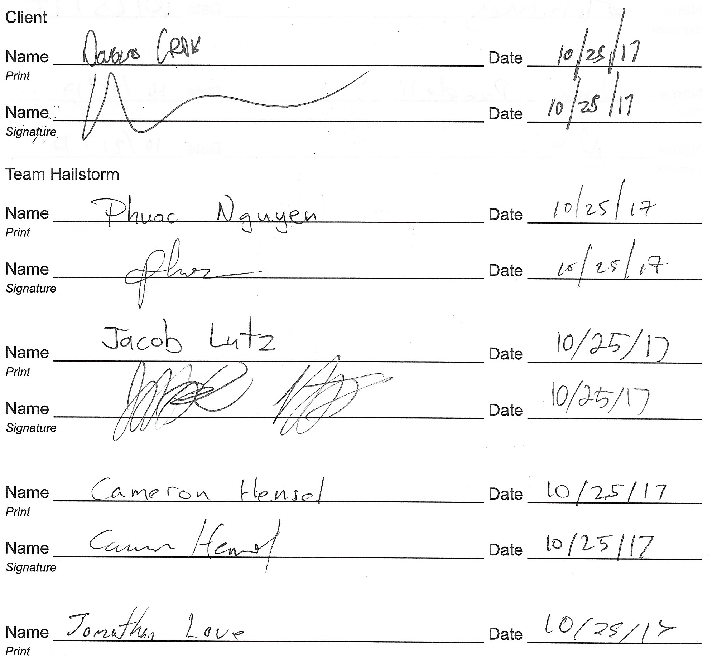

## 

## 

## **Appendix B – Team Review Sign-off**

This document has been collaboratively written by all members of Team Hailstorm, and all members have reviewed the document and have agreed upon its contents. If any member bears disagreements regarding the contents of this document, such disagreements will be written in the comments below.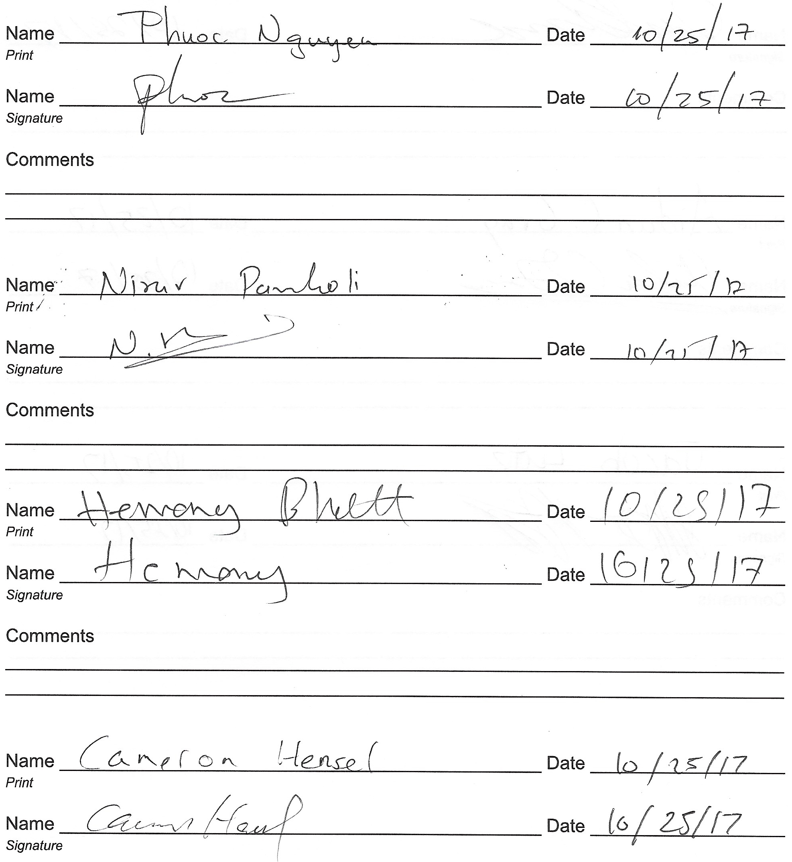

## 

## 

## **Appendix C – Document Contributions**

All team members contributed to the text descriptions of this document. Additionally,Aidan Gray created all diagrams, images, and tables, and Jacob Lutz edited the text descriptions for grammar consistency.